PF Lab work  
  
**Q1**

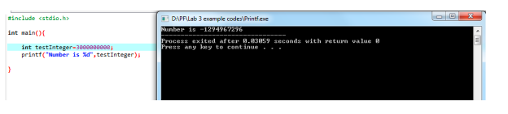

Ans: The code does not work because the value stored as an integer in the variable “testInteger” is too large.

**Q2**

Code: 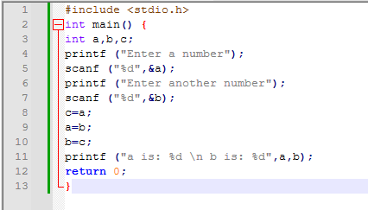

Output: 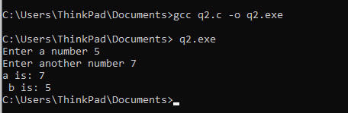

**Q3:**

Code: 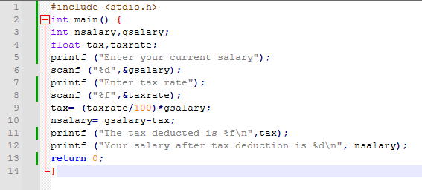

Output: 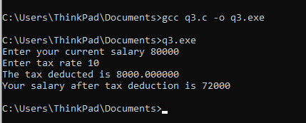

**Q4:**  
Code: 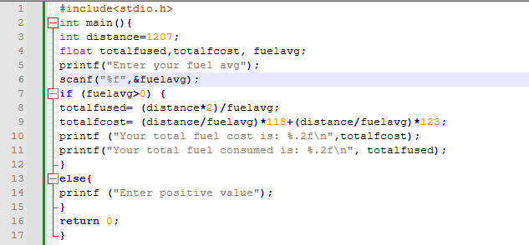  
  
Output: 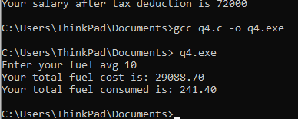

**Q5:**  
Code: 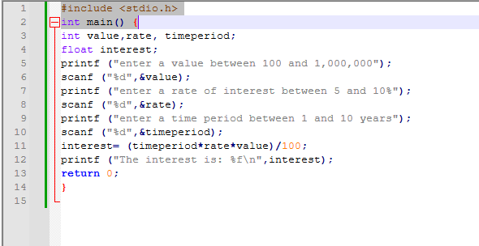

Output: 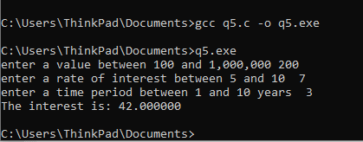

**Q6:**  
Code: 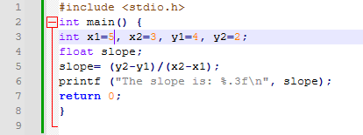

Output: 